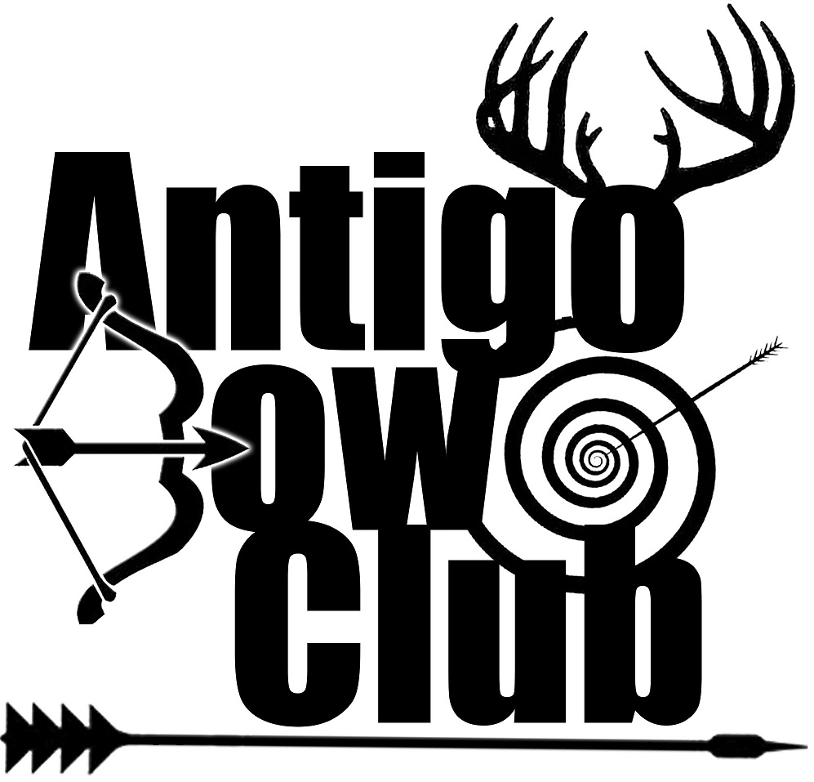
Dan Houdek, President

N2230 Maxwell Lake Rd.
Antigo, WI 54409
Phone: (715) 627-4543
Cell Phone: (715) 527-0379
Fax: (715) 627-0906
E-mail:dhoudek@antigo.k12.wi.us

www.antigobowclub.com

December 30, 2014

Dear Area Business,

The Antigo Bow Club, a non-profit organization, is in our 20th year of service in the community of Antigo. In the past, your support has been shown through the purchase of a sign at the club’s indoor facility. We appreciate your support and ask that you continue that support by renewing your sign contract for the 2015 season.
In 2014, the facility was used by over 250 children in the Youth Archery, Jr. Archery League, Boy Scouts, Wisconsin Hunter’s Education and 4H Programs. In addition to our quickly growing youth program the club is home to about 150 active members. The youth programs and adult leagues utilize our facility six days a week from January through April. Other Activities include three banquets and our fishing seminar/raffle. Future financial needs include supporting the growth of our youth programs as well as general memberships, continued support of the Hunter’s Safety gun/bow program, and purchases of more shooting supplies to ensure the growth of all classes of shooters. In less than a years, when payment of the indoor facility is complete, the club plans to give even more back to the community through the gift of scholarships and support to more programs.
We ask that you consider donating to the Antigo Bow Club through the purchase of an advertisement. Your purchase will help to continue the existing programs as well as help to achieve our future goals. If you have questions feel free to contact Dan Houdek, club president, at 715-627-4543.

___ We would like a one year sign commitment in the shooting area for $100
___ We would like a one year sign commitment in the lobby area for $200

Business Name and Contact Person _________________________________________________
Business Address _______________________________________________________________
City, Zip, and Phone Number _____________________________________________________

Please make checks payable to: Antigo Bow Club (P.O. Box 555, Antigo, WI 54409)

Antigo Bow Club officers: Dan Houdek, President; Doug Jensen, Vice President; John Ponasik, Treasurer; Tom Beattie, Secretary

